Data analysts collect, clean, and interpret complex data sets to solve business problems, using key skills like SQL, Excel, and data visualization (Tableau/Power BI). Key tasks include writing queries, creating automated dashboards, performing statistical analysis, and communicating actionable insights to stakeholders.

Core Data Analyst Tasks
Data Collection: Gathering data from primary and secondary sources, including databases, APIs, and web scraping.
Data Cleaning/Wrangling: Filtering, cleaning, and validating data to remove errors, missing values, and inconsistencies.
Data Analysis: Identifying, analyzing, and interpreting trends or patterns in complex data sets using statistical techniques.
Data Visualization & Reporting: Creating dashboards, graphs, and reports (Tableau/Power BI) to communicate findings to stakeholders.
Database Management: Developing and implementing databases and data systems to improve data quality and efficiency.
Strategic Consulting: Working with management to prioritize business needs and identifying process improvements.

Essential Skills & Tools
SQL (Structural Query Language): Non-negotiable for querying, filtering, and joining data from databases.
Spreadsheets (Excel/Google Sheets): Essential for data manipulation, pivot tables, and quick, ad-hoc analysis.
Data Visualization Tools: Proficiency in Tableau, Power BI, or Looker to create interactive dashboards.
Programming Languages: Python or R are frequently used for data manipulation, cleaning, and advanced analysis (Pandas, NumPy libraries).
Statistics & Math: Understanding data distributions, correlations, and statistical tests to ensure accurate analysis.
Communication & Data Storytelling: Ability to translate technical findings into actionable business insights for non-technical audiences.
AI Fluency: Using AI tools like ChatGPT or Copilot to assist with query writing, code generation, and data summarizing.

What is Data Analysis Lifecycle?
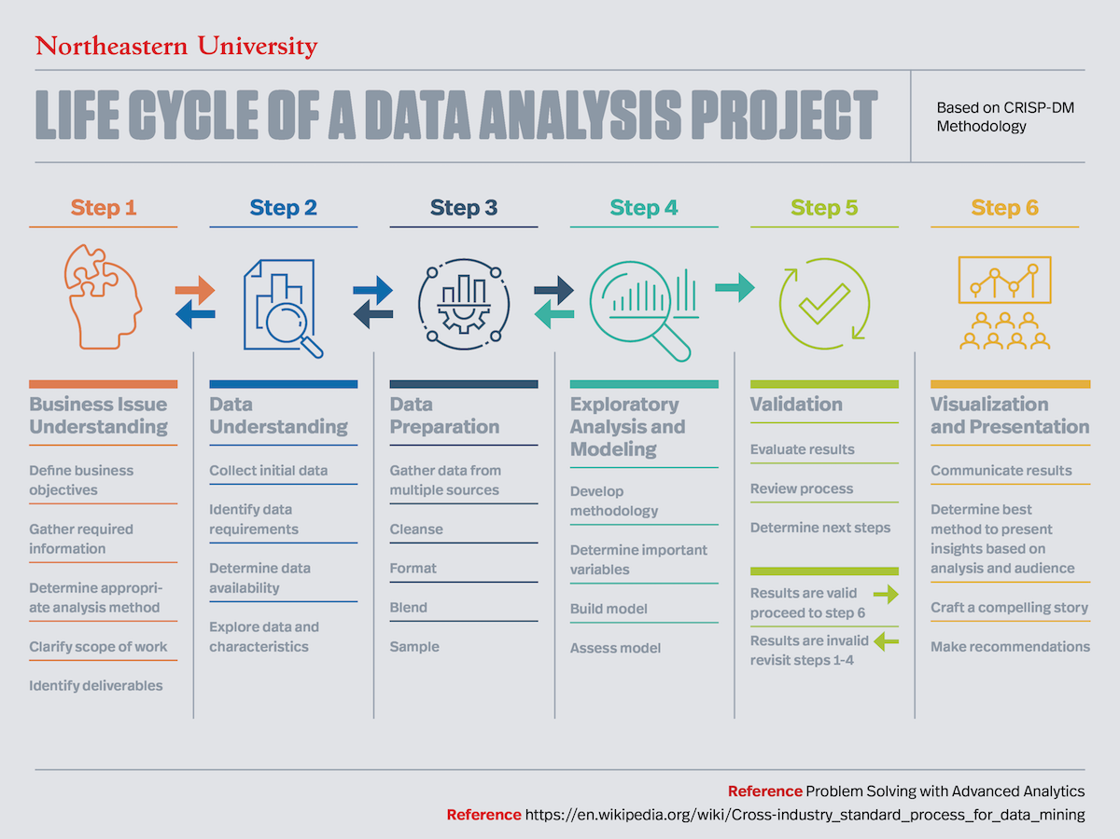
The data analysis lifecycle describes the process of conducting a data analytics project, which consists of six key steps which include:
understanding the business issue, understanding the data set, preparing the data, exploratory analysis, validation, and visualization and presentation.

6 Steps in the Data Analysis Process
1. Understand the Business Issues
When presented with a data project, we will be given a brief outline of the expectations. From that outline, we should identify the key objectives that the business is trying to uncover. We should examine the overall scope of the work, business objectives, information the stakeholders are seeking, the type of analysis they want we to use, and the deliverables (the outputs of the project) they want.
We need to have these elements clearly defined prior to beginning the data analysis project to provide the best deliverable we can. Additionally, it’s important to ask as many questions as we can at the outset of the project because, often, we may not have another chance before the completion of the project.
2. Understand the Data Set
There are a variety of tools we can use to organize the data. When presented with a small dataset, we can use Excel, but for heftier jobs, we’ll likely want to use more rigid tools to explore and prepare workplace data. R, Python, Alteryx, Tableau Prep or Tableau Desktop to help prepare the data for its cleaning.
Within these programs, we should identify key variables to help categorize the data. When going through the data sets, look for errors in the data. These can be anything from omitted data, data that doesn’t logically make sense, duplicate data, or even spelling errors. These missing variables need to be amended so we can properly clean the data.
3. Prepare the Data
Once we have organized and identified all the variables in the dataset, we can begin cleaning. In this step, we will input missing variables, create new broad categories to help categorize data that doesn’t have a proper place, and remove any duplicates in the data. Imputing average data scores for categories where there are missing values will help the data be processed more efficiently without skewing it.
4. Perform Exploratory Analysis and Modeling
In this step, we will begin building models to test the data and seek out answers to the objectives given. Using different statistical modeling methods, we can determine which is the best for the data. Common models include linear regressions, decision trees, and random forest modeling, among others.

5. Validate The Data
Once we have crafted the models, we’ll need to assess the data and determine if we have the correct information for the deliverable. Did the models work properly? Does the data need more cleaning? Did we find the outcome the client was looking to answers? If not, we may need to go over the previous steps again. We should expect a lot of trial and error!
6. Visualize and Present the Findings
Once we have all the deliverables met, we can begin the data visualization. In many cases, data visualization will be crucial in communicating the findings to the client. Not all clients are data-savvy, and interactive visualization tools like Tableau are tremendously useful in illustrating the conclusions to clients. Being able to tell a story with the data is essential. Telling a story will help explain to the client the value of the findings.
As with any project, we need to identify the objectives clearly. Outlining the work will ensure we get the best deliverables for the clients. While all of these steps are important, if we start the project without all the data we need, we are likely to have to backtrack.

Below is a real-life Data Analysis Project Summary using Pandas, Matplotlib, and Pydataset:
Project Title:
Survival Analysis of Titanic Passengers Using the ‘titanic’ Dataset
Objective
The goal of this project was to analyze passenger data from the Titanic to understand which factors influenced survival rates. The analysis focused on demographic variables such as age, gender, and passenger class, using pandas for data manipulation and matplotlib for visualization.
Dataset
The dataset used was “titanic”, loaded from the pydataset library. It contains 1,309 passenger records with variables including:
- pclass (passenger class)
- sex
- age
- survived
- sibsp (siblings/spouses aboard)
- parch (parents/children aboard)
- fare
This dataset is widely used for statistical modeling and classification tasks.
Tools & Libraries Used
- pandas for data cleaning, transformation, and analysis
- matplotlib.pyplot for visualizations
- pydataset to load the Titanic dataset easily
Data Loading & Preparation
python
from pydataset import data
import pandas as pd
import matplotlib.pyplot as plt

df = data('titanic')
Data Cleaning Steps
- Removed rows with missing values in age and fare
- Converted survived and pclass into categorical variables
- Created a new column age_group (child, adult, senior)
python
df = df.dropna(subset=['age', 'fare'])
df['pclass'] = df['pclass'].astype('category')
df['survived'] = df['survived'].astype('category')

Exploratory Data Analysis (EDA)
1. Survival Rate Overview
- Overall survival rate: ~38%
- Women had a significantly higher survival rate than men
- First-class passengers survived at much higher rates than third-class passengers
2. Group Analysis Using Pandas
python
df.groupby('sex')['survived'].mean()
df.groupby('pclass')['survived'].mean()
Findings:
- Female survival rate: ~74%
- Male survival rate: ~19%
- 1st class survival: ~63%
- 3rd class survival: ~24%
Visualizations (Using Matplotlib)
1. Bar Chart: Survival Rate by Gender
python
df.groupby('sex')['survived'].mean().plot(kind='bar', color=['purple','orange'])
plt.title("Survival Rate by Gender")
plt.ylabel("Survival Rate")
plt.show()
This chart clearly showed that women were far more likely to survive.
2. Bar Chart: Survival Rate by Passenger Class
python
df.groupby('pclass')['survived'].mean().plot(kind='bar', color='skyblue')
plt.title("Survival Rate by Passenger Class")
plt.ylabel("Survival Rate")
plt.show()
First-class passengers had the highest survival rate.
3. Histogram: Age Distribution
Most passengers were between 20 and 40 years old.
Key Findings:
- Gender was the strongest predictor of survival — women had a much higher chance of surviving.
- Passenger class played a major role — first-class passengers had better access to lifeboats.
- Children had higher survival rates compared to adults, supporting the “women and children first” evacuation pattern.
- Third-class passengers had the lowest survival rate, likely due to cabin location and restricted access to lifeboat areas.
Conclusion
Using pandas, matplotlib, and pydataset, this project provided a clear analysis of the factors influencing survival on the Titanic. The results highlight how social and economic factors — such as gender and class — significantly affected survival outcomes. This project demonstrates how data analysis can uncover meaningful patterns in historical events.

